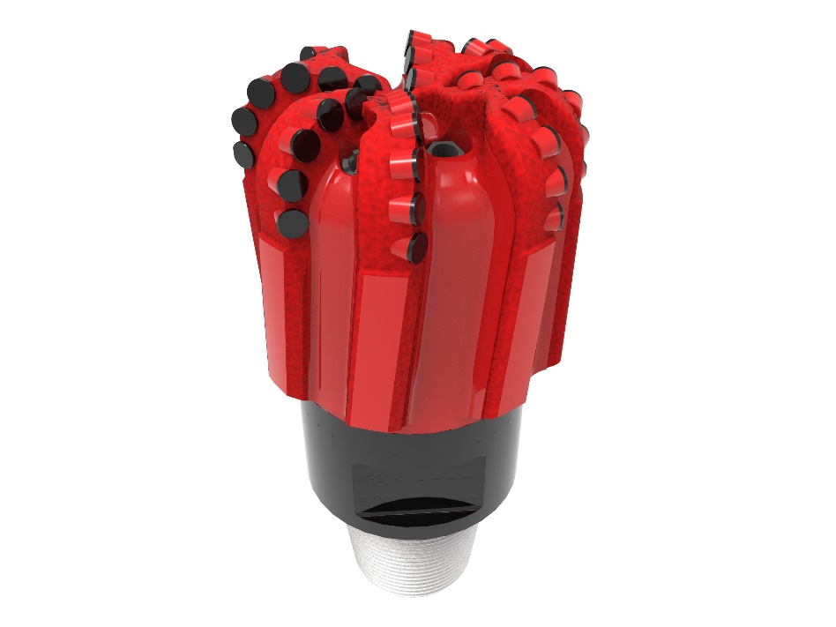
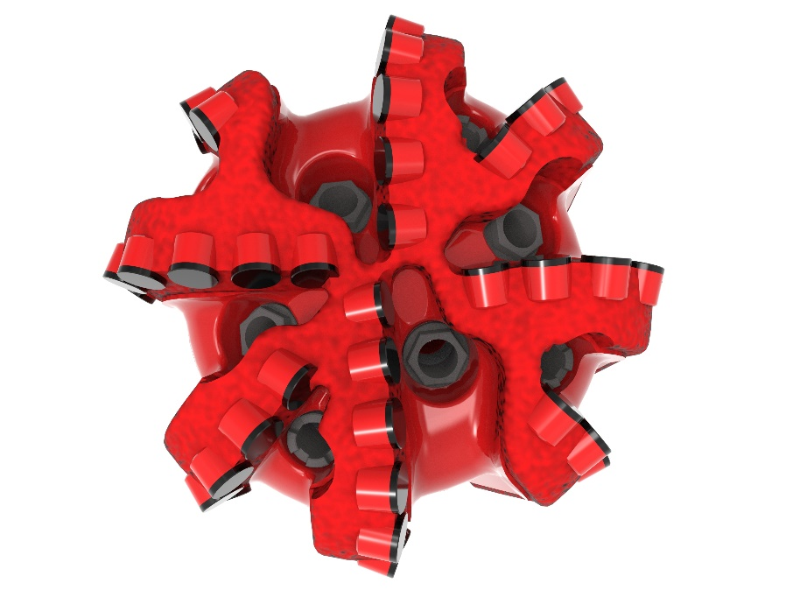

Drill Bit Specifications:
Cutter Size (Primary, Sec) | 5/8”
Cutter Count (Total, Gage) | 43, 8
Blade Count | 4
Gage Length (Inches) | 4.00
Nozzle Count (Primary, Sec.) | 4, 4
Nozzle Series (Primary, Sec.) | 60, 45
JSA (Sq. Inches) | 9.29
Max. TFA (Sq. Inches) | 2.27
Operating Parameters:
Max. Weight on Bit (1,000 Lbs.) | 60
Make-up Torque (ft/lbs) | 17,399
Nominal Dimensions:
Overall Length (Inches) | 14.85
Make Up Length (Inches) | 10.72
Bit Breaker | SKB-21010
Connection | Ø4-1/2" API Reg.
Approx. Weight (Lbs.) | 100

Standard Features:

- Premium grade cutters maximize ROP and Life
- Nozzle configuration and large open face volume optimize blade cleaning and cuttings removal
- Double blade design extends bit life for increased footage

416-XB8 Nomenclature Explained:

• | 4 | = | Number of blades
• | 16 | = | Primary Cutter Size (16mm)
• | XB | = | Backup Cutters & Double Blade
• | 8 | = | Number of Nozzles


